**Ideation Phase**

**Brainstorm & Idea Prioritization Template**

|  |  |
| --- | --- |
| Date | 11 October 2022 |
| Team ID | PNT2022TMID36178 |
| Project Name | A Novel Method for Hand Written Digit Recognition |
| Maximum Marks | 4 Marks |

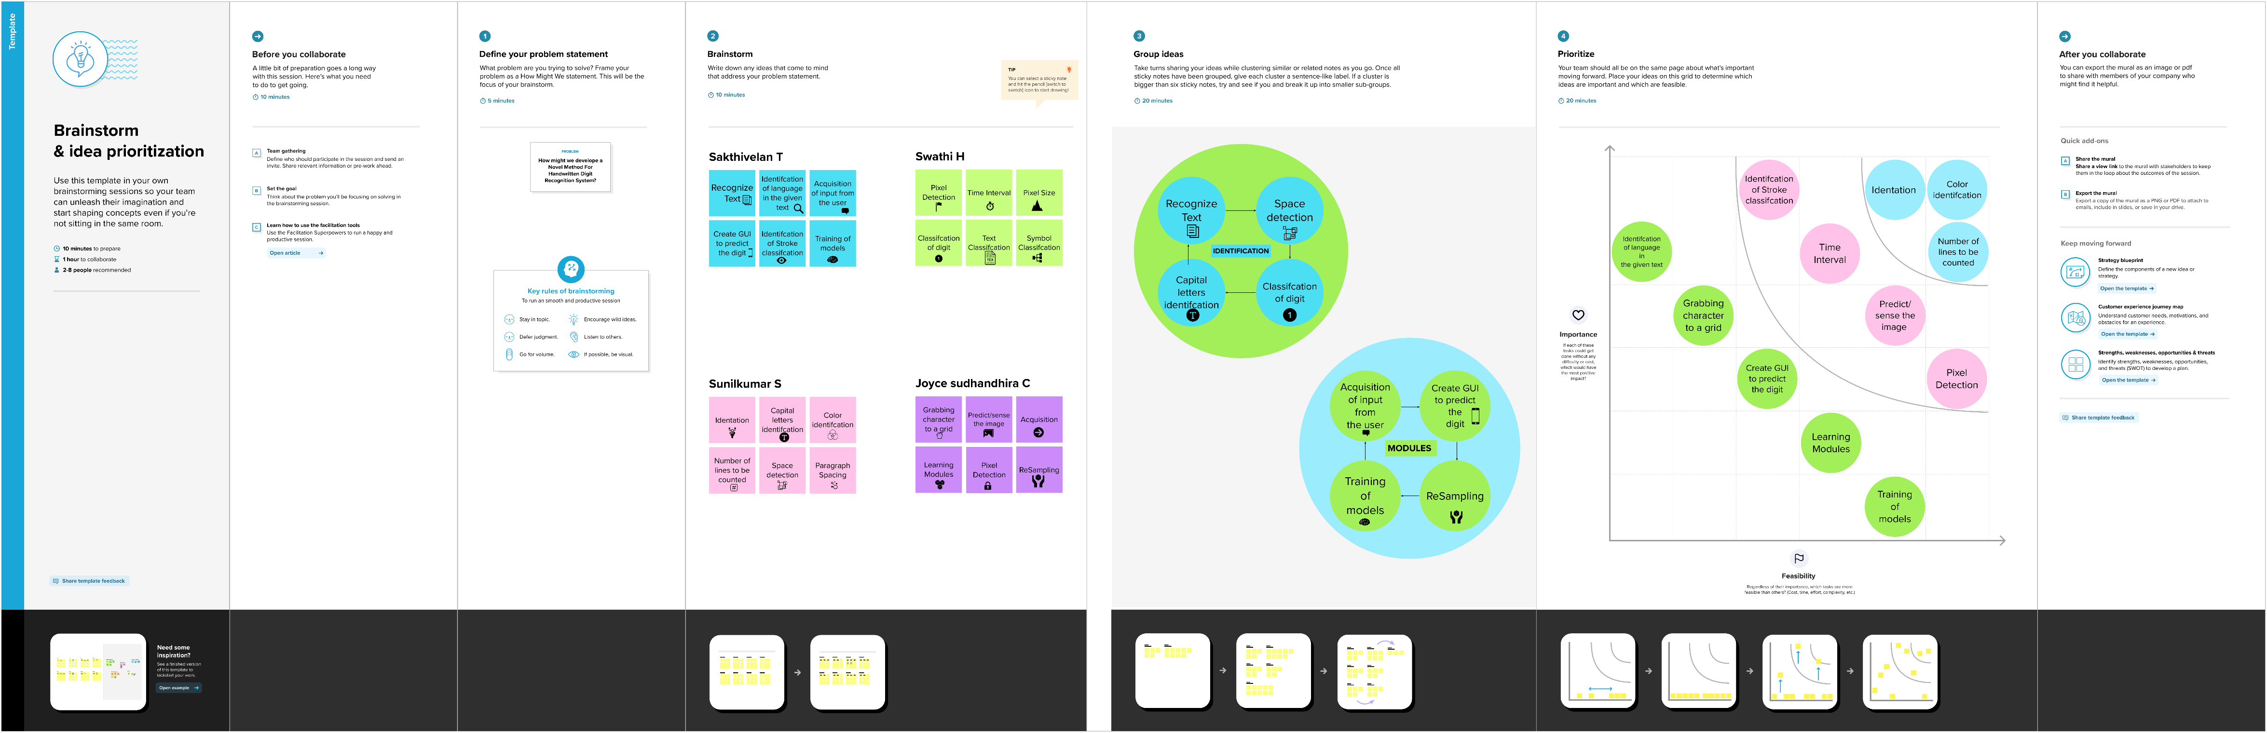

**Brainstorm, Idea Listing and Grouping**

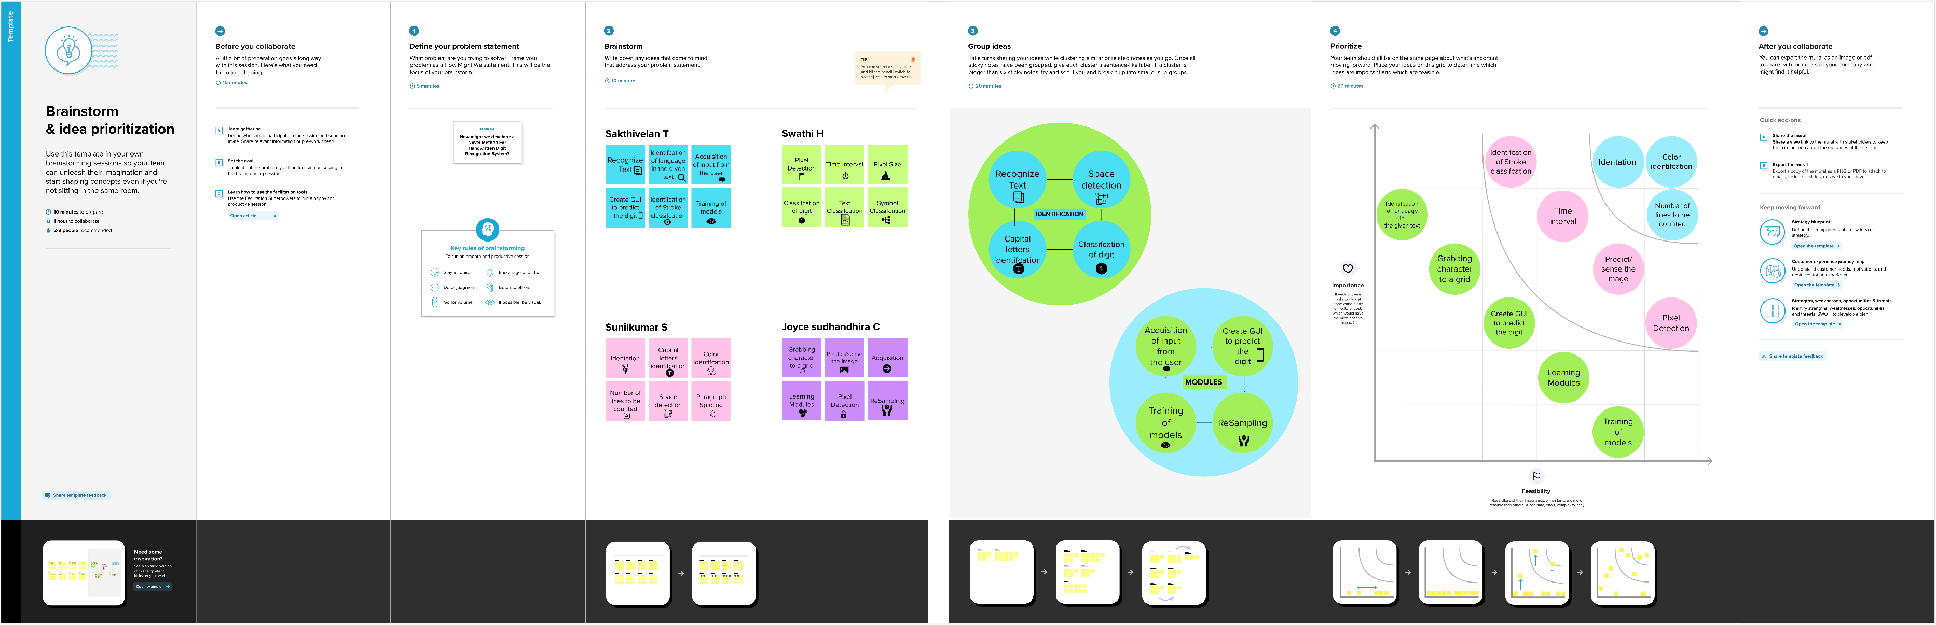

**Idea Prioritization**

